**Part 1 – Clawbot Build**

Before beginning to build, we gathered most of the materials to make the building process go smoother. During the construction of our robot, we faced a few minor issues with placement. We would accidentally screw a piece in the wrong spot or misinterpret the instructions. This meant that when we got to future steps, we would have go back and fix things, making our building process take much longer. Other than those few mishaps, it went smoothly. If there was a part that was needed but we didn’t have (ex. a certain sized screw), Irene would go and get it while Priyanka would continue to build.

**Part 2 – Programming**

This part posed as the most challenging (and frustrating) aspect. Our code would have to be constantly adjusted because of the turning inconsistencies. The starting point of our robot would affect the execution of the code, leading to faulty test runs, but we were able to place it in almost the same spot after a few runs. While coding, we had a few issues with using the wrong commands which led to the robot stopping suddenly. There was also point where we were misreading the code, making us believe that it was skipping steps.

**Port Assignments:**

The drivetrain motors were in ports 6 and 10, the motor that controlled the arm moving up and down was in port 3, and the motor that controlled the claw opening and closing was in port 4.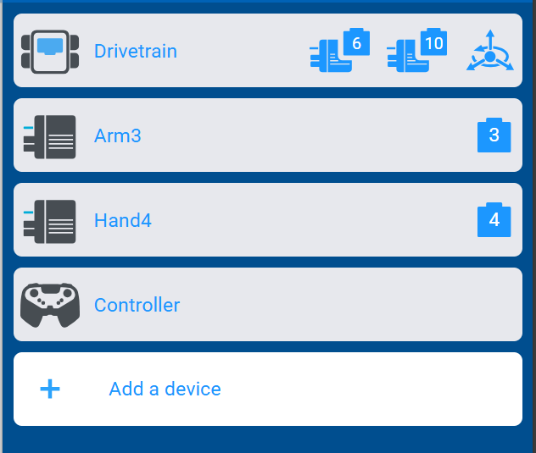

**Code:**

Our code begins with Dex facing the stacking area and then turning around to go towards the blocks. Dex drives up to the area and grabs the first block on the top. He then turns around and goes to place it in the stacking area. Dex then goes back to grab another block, and if the fates align, he places it on top of the other block in the stacking area. If not, he either turned a little too much or not enough. For the third time, Dex will go back to grab yet another block and turn around. The arm goes up enough to place the block on top of the other two blocks. Dex has never been able to stack three blocks; his record is two.